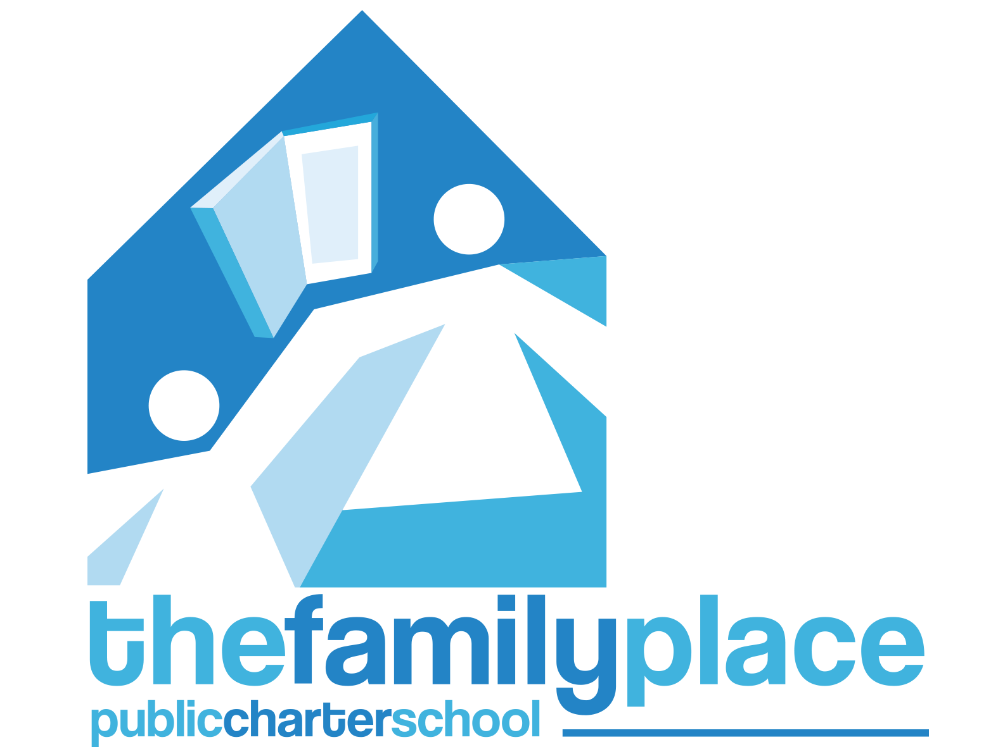
Minutes
(Pending Approval)
The Family Place Public Charter School
Date | time August 17, 2021 | 6:30pm - 7:30pm | Location Virtual Meeting, Zoom

In Attendance
BOARD MEMBERS
NAME | PRESENT | ABSENT
Mavis I. Ardon | x
Ann B. Barnet | x
Michael D. Barnet | x
Shawn Chakrabarti | x
Dania Diaz Amaya |  | x
Barbara Finkelstein |  | x
Sarah Friedman | x
Natalia Isaza Brando | x
Marcia Harrington | x
Oralia Puente | x
Elaine Weiss | x

Others Present:
Haley Wiggins, Patricia Oholeguy, Miryam Acosta, Laurel Kircher, Fernando Saldana, Dr. Lawrence Bussey, Eileen Suffian.

Approval of Minutes
Minutes Approved for June 16 Board Meeting as written. Roll Call completed.

Motions

Description of Matters Discussed
- Graduation was a Great Event and description was provided about the event, modifications were made to do a walk-through with photo opportunities and acknowledgement.

-Vaccinations:
Policy that Mayor and DC is placed and following the order; to show proof of vaccination or proof of weekly negative COVID test.
- Staff is all vaccinated except for one member.
- Students are the next challenge on how to gather information regarding vaccinations.
- We will be participating in an OSSE program to test students at the school.
- All day-time classes are in person. We are providing evening virtual classes, with the exception of Foundations of Literacy (Spanish Class) and a Multi-Level ESL class taught in person.
- We will provide a copy of the OSSE COVID Guidelines submitted for prevention and mitigation.
- Discussed how we can educate the community by bringing a Dr. to discuss the benefits of the vaccine.
- We know that we have a percentage of students that are vaccinated, and we have now learned that we can ask for this information, so we will be collecting this information.
- Plan another presentation event to talk to families and continue with our vaccine education efforts during the fall semester. During early October.

Executive Director Report
- EdOps had no new information to report on financials since we just finished one year and began another one.
- Receiving additional funding from 146K through the SOAR Grant, which is less than we were expecting.
- We are also getting 80K for facilities, that will help us offset the renovations.

Academic Report
- Hiring and replacing teachers for adult learning classes.
- Classes will be smaller, Foundations of Literacy, CDA and Multi Level ESL classes.
- Virtual Classes will continue for all ESL levels with a capacity of 20 students using ZOOM as a learning platform.
- Four morning classes, three afternoon classes, and Five in the evening.
- Health Protocols were presented
- Class starts on August 30th, 2021.
- Attendance will have a more solid structure compared to previous year.
- Planning to provide Hotspots and Laptops to students as appropriate to increase academic success.
- Digital Literacy support and Technical Support will be provided.

Compliance Report
- Four weeks of registration completed
- 325 Applicants were contacted and 182 registrations were processed.
- Home visits are going to be completed for those who don’t have all the paperwork to demonstrate proof of DC residency.

Building Updates
- Challenging to find a space that will allow for a dual generation program.
- One option is to rent space from the Festival Center for now until we can buy (Contact Dr. Barnet).
- Two generation model will always be part of the program and mission
- The current building expansion at 3309 16th Street. Is only helpful for the moment, since we are outgrowing our space capacity.
- Waiting on city approval to have basement ready for academic year.

Next Meeting
Motion to adjourn the meeting was made and was passed unanimously.

