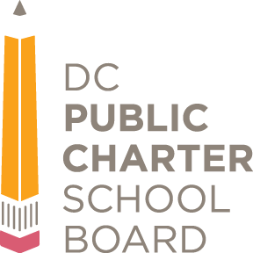Notice of Petition to Amend Charter

Goals – **Carlos Rosario PCS**

Open for Public Comment

**Public Comment Accepted Until: December 16, 2024**

**SUMMARY**: The District of Columbia Public Charter School Board (DC PCSB) announces an opportunity for the public to comment on a request from Carlos Rosario International Public Charter School (Carlos Rosario PCS) to amend its charter by modifying its goals and academic achievement expectations (charter goals). The school submitted its request on November 12, 2024.[1]

Currently in its 26th year of operation, Carlos Rosario PCS educates 2,165 adult education students at a single campus across two facilities in Ward 1. The school’s mission is to “deliver high-quality education, career training, and supportive services that enable adult immigrants to realize their dreams while strengthening our community and economy.”

Carlos Rosario PCS seeks to remove its In-Seat Attendance (ISA) charter goal for school year (SY) 2024 – 25 and beyond. The school is proposing this change because attendance is not compulsory for adult education students. Further, DC PCSB’s accountability system, ASPIRE (effective SY 2024 – 25), no longer includes ISA as a measure within the School Environment category of its adult education framework.

**PUBLIC MEETINGS**: The public hearing will be on December 16, 2024 at 6 p.m. The vote will be on January 27, 2025 at 6 p.m. Please check [www.dcpcsb.org](http://www.dcpcsb.org) to register to attend the virtual meetings.

**HOW TO SUBMIT PUBLIC COMMENTS**:You may submit comments by any one of the methods listed below.[2]

1. Testify during the public meeting on December 16, 2024. To register, please visit <https://dcpcsb.org/public-comment>. Click “Sign up to Testify at the Meeting,” then complete the form. Please note you must sign up no later than noon on December 16, 2024.
2. Submit a written comment on or before 11:59 pm the day before the public meeting via:
3. “Submit a Written Comment” at <https://dcpcsb.org/public-comment>.
4. Postal mail, hand delivery, or courier:Attn: Public Comment, DC Public Charter School Board, 100 M Street SE, Suite 400, Washington, DC 20003
5. Submit voicemail testimony by calling (202) 328-2660 and select option 2. You will have up to five minutes to record your testimony. All comments will be transcribed and made available to the public upon receipt.

**FOR FURTHER INFORMATION, CONTACT**: Starling Temp, a Senior Specialist in the School Performance Department, at [stemp@dcpcsb.org](mailto:stemp@dcpcsb.org).

1. Pursuant to the School Reform Act, D.C. Code 38-1802 et seq., a charter school must submit a petition to revise its charter.
2. DC PCSB reserves the right, but shall have no obligation, to review, pre-screen, filter, redact, refuse or remove any or all your submission that it may deem to be inappropriate for publication, such as obscenities.